***PP290: Stata- Final Project________________________ ___***

**Race and Returns to Education**

*By: Inthisar Kamal*

Table of Contents

Summary of Dataset …………………………………………………………………………………………2

Appendix A: Codebook………………………………………………………………………………………………………6

Appendix B: Code…………………………………………………………………………………………………………....8

**Contents of dataset**

This dataset is composed of variables that were merged from three different datasets related to different levels of education. It primarily focuses on both fifth-grade achievement scores and returns to college education in 2004. The survey is composed of 32,042 households. The first set of variables are related to fifth grade reading and math scores in 2004 while variables from the second and third dataset look at college graduation rates (science test scores were dropped as not all states had standardized science tests). Among the variables included are also socio-economic, family background and lastly race indicators. The data from the survey is used to document the relationship between race and education achievement. While the race labels are not all encompassing the data categorizes ethnicity into four dummy variables; White, Black, Hispanic and Other.

**Comparing Average Math and Reading Scores by Race**

|  |  |  |
| --- | --- | --- |
| **5th grade Reading Score Distribution Breakdown** | | |
|  |  |
| Percentiles | | | Smallest |
| 1% 71.68761 | | | 63.0874 |
| 5% 81.75681 | | | 63.30107 |
| 10% 86.41749 | | | 63.63493 | Obs | | 8,105 | |
| 25% 93.66891 | | | 64.03556 | Sum of Wgt. | | 8,105 | |
| 50% 101.5302 | | | Mean | 100 | |  | |
| Largest | | | Std. Dev. | 10 | |  | |
| 75% 107.7444 | | | 117.4619 |  |  | |
| 90% 112.1425 | | | 117.4931 | Variance | | 99.99999 | |
| 95% 113.8118 | | | 117.4931 | Skewness | | -.67794 | |
| 99% 115.8683 | | | 117.6534 | Kurtosis | | 3.172477 | |

|  |  |  |
| --- | --- | --- |
|  | **5th Grade Math Score Distribution Breakdown** | |
|  | |  |  |
| Percentiles | Smallest |  |
| 1% | | 72.52747 | 66.5212 |
| 5% | | 80.14838 | 66.53579 |
| 10% | | 85.25005 | 66.54066 | Obs | | 8,105 |
| 25% | | 94.2862 | 66.56497 | Sum of Wgt. | | 8,105 |
| 50% | | 101.8439 | Mean | 100 | |  |
|  | | Largest | Std. Dev. | 10 | |  |
| 75% | | 107.5292 | 116.8279 |  | |  |
| 90% | | 111.5025 | 117.0857 | Variance | | 99.99999 |
| 95% | | 113.1512 | 117.0857 | Skewness | | -.7970415 |
| 99% | | 115.3981 | 117.0857 | Kurtosis | | 3.179688 |

*Table 1: Table 2:*

**Summary of 5th grade Math Score Summary of 5th grade Reading Score**

*Table 3: Table 4:*

|  |  |
| --- | --- |
|  | (1) (2) (3) |
| VARIABLES | Mean Std.Dev. Freq |
|  |  |
| White | 102.04356 8.9465693 5,063 |
| Black | 92.463335 10.264275 733 |
| Hispanic | 96.213186 10.31866 1,465 |
| Other | 100.8596 10.206753 844 |
| Total | 99.999999 9.9999995 8,105 |
|  |  |

|  |  |
| --- | --- |
|  | (1) (2) (3) |
| VARIABLES | Mean Std.Dev. Freq |
|  |  |
| White | 102.26931 8.9978369. 5,063 |
| Black | 93.725811 10.274655 733 |
| Hispanic | 95.41872 10.116199 1,465 |
| Other | 99.787927 10.203333 844 |
| Total | 99.999999 9.9999995 8,105 |
|  |  |

***Findings:***

Our data shows that in this sample, white students had higher average scores than Black, Hispanic and other students. The average math and reading score associated with White students lies just above the 50th percentile of the overall math and reading distribution. Hispanic students had a higher average reading and math score than Black students. Their average lay above the 25th percentile in the distribution. Black students had the lowest average standardized test score when compared to the rest with the average score lying below the 25th percentile. The average test score for Hispanic and Black students do not differ significantly but there is a wider gap when compared to the average score associated with white students.

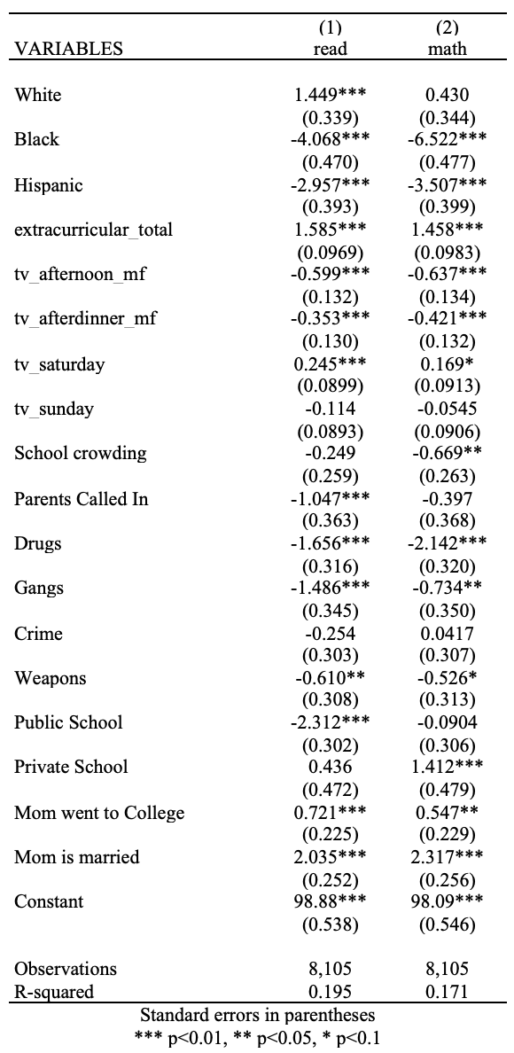**Regression analysis summary for Reading and Math Scores**

***Findings:***

Key thing to note is that upon regressing school indicators, family background and race on math and reading scores, the variance in these indicators explain only 20% of the variation in the reading and math scores. The ‘other’ race category was omitted to avoid perfect collinearity. The data states:

* Among the variables, mothers’ marital status had the strongest relationship with math and reading scores. This is also statistically significant. Students whose mothers were married scored roughly two points greater than students whose mothers were not married
* Students whose mothers went to college scored 0.7 and 0.5 points higher on average than students whose mothers did not go to college
* White students scored 1.5 points higher on average than non-white students in reading, holding all other factors constant. This is statistically significant (whereas they scored .43 points higher in math but this is not statistically significant)
* Black students scored 4.07 points lower on average than non-black students in reading and 6.5 points lower on average in math, holding all other factors constant. Both of these coefficients are statistically significant
* Hispanic students scored 3 points lower on average than non-Hispanic students in reading and 3.5 points lower on average in math, holding all other factors constant. Both of these coefficients are statistically significant
* Extra-curricular activities played a significant role as well. Each additional part time activity that a child was involved in was associated with a 1.5 point increase in their reading and math score
* Schools that had issues with Drugs, Gangs, Crime and Weapons seemed to score lower on average than schools that did not have these issues
* Public school students scored lower on average while private school students scored higher on average

|  |  |  |  |  |  |  |  |  |  |  |
| --- | --- | --- | --- | --- | --- | --- | --- | --- | --- | --- |
| Variables | (1) | (2) | (3) | (4) | (5) | (6) | (7) | (8) | (9) | (10) |
| (1) family_income | 1.000 |
| (2) total_testscore | 0.302 | 1.000 |
| (3) extra-curricular | 0.232 | 0.279 | 1.000 |
| (4) public_school | -0.207 | -0.166 | -0.172 | 1.000 |
| (5) private_school | 0.148 | 0.105 | 0.077 | -0.525 | 1.000 |
| (6) white | 0.223 | 0.298 | 0.182 | -0.141 | 0.083 | 1.000 |
| (7) black | -0.145 | -0.234 | -0.096 | 0.082 | -0.024 | -0.407 | 1.000 |
| (8) Hispanic | -0.172 | -0.211 | -0.163 | 0.101 | -0.076 | -0.606 | -0.148 | 1.000 |
| (9) mom married | 0.212 | 0.217 | 0.159 | -0.107 | 0.041 | 0.185 | -0.273 | -0.040 | 1.000 |
| (10) mom_education | 0.391 | 0.444 | 0.353 | -0.247 | 0.132 | 0.312 | -0.098 | -0.331 | 0.184 | 1.000 |
|  | | | | | | | | | | |

**Correlation between race and other variables that have an association with reading and math scores**

***Findings***

After running the regression and seeing how the variables were associated with the scores it was striking how much larger the coefficients associated with race were compared to other indicators. Therefore, this analysis compared the correlation between race and the other variables. None of the correlations were particularly strong in either direction. What was insightful was that White students who scored higher scores on average compared to non-White students, were positively correlated with the variables that had a positive association with the scores. For example, White students were positively correlated with family income, extracurricular activities and mothers’ education level, variables that Hispanic and Black students shared a negative correlation with.

**College Graduation**

***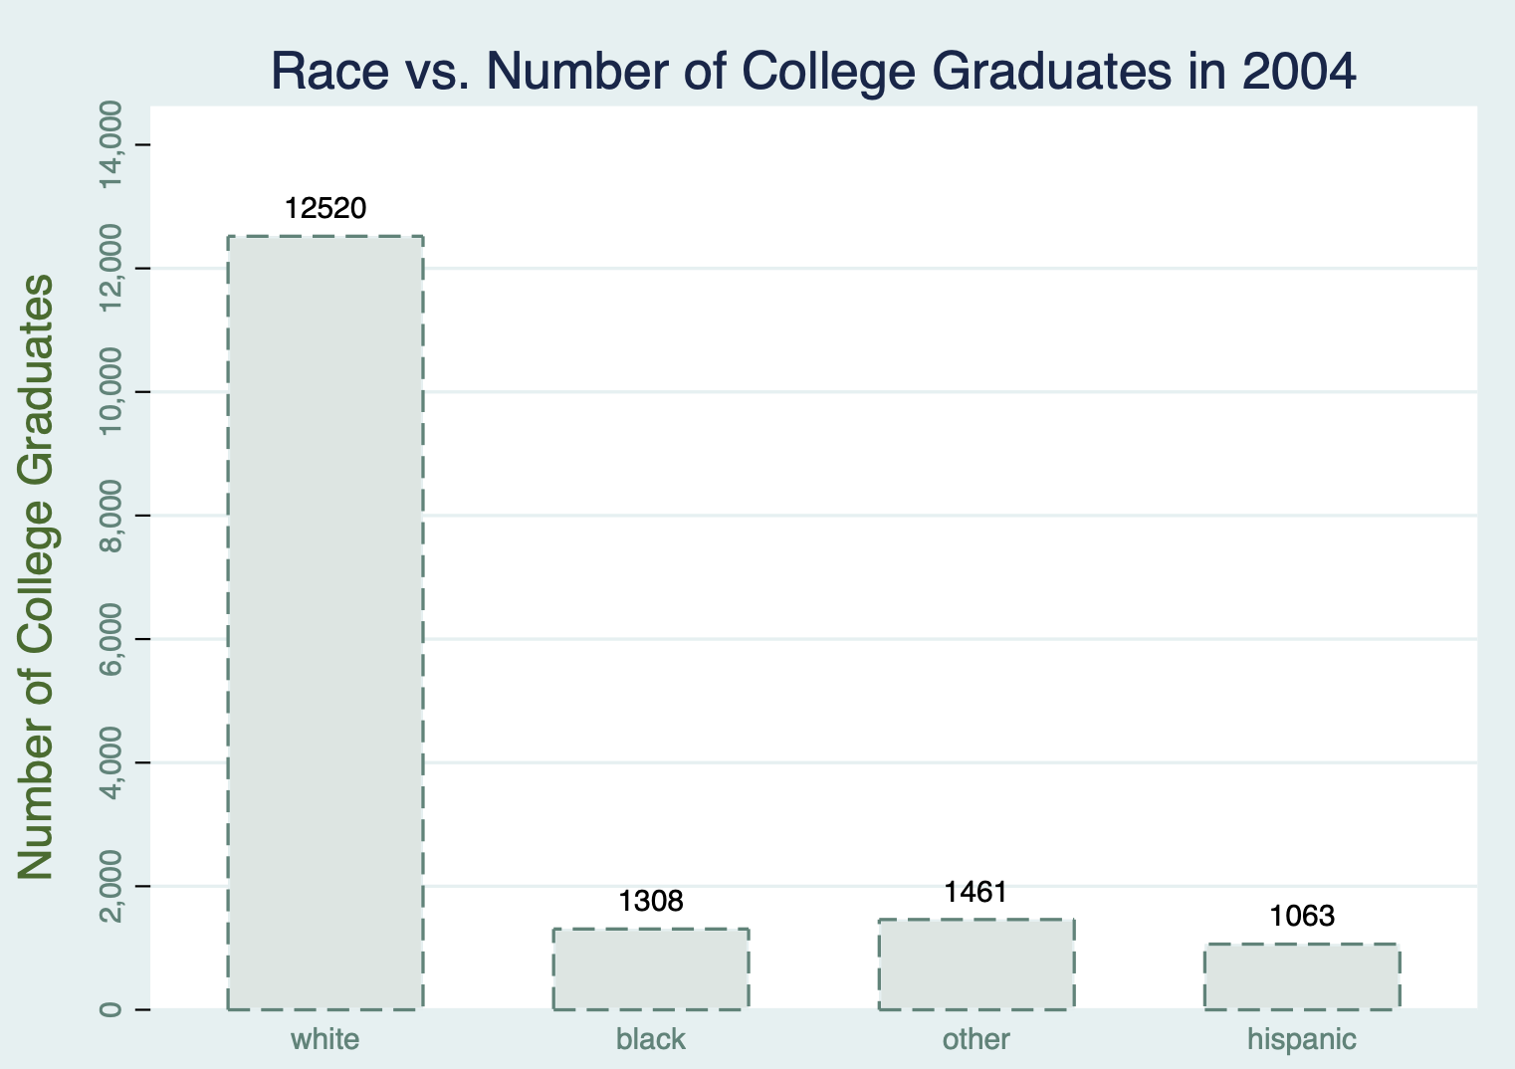*Tabulation of Race v. College Graduation**

|  |  |  |  |
| --- | --- | --- | --- |
| race | =1 if college grad, =0 if high school | | |
|  | 0 | 1 | Total |
| White | 10536 | 12520 | 23056 |
|  | *45.70* | *54.30* | **100.00** |
| Black | 1955 | 1308 | 3263 |
|  | *59.91* | *40.09* | **100.00** |
| Other | 850 | 1461 | 2311 |
|  | *36.78* | *63.22* | 100.00 |
| Hispanic | 2349 | 1063 | 3412 |
|  | *68.85* | *31.15* | **100.00** |
| Total | 15690 | 16352 | 32042 |
|  | 48.97 | 51.03 | 100.00 |
| First row has *frequencies* and second row has *row percentages* | | | |

***Findings***

We merged this dataset with two datasets showing returns to college and race in 2004 to see if the same trends are apparent. Among White students it is almost even split with 45% having not graduated from college. Among Black students the proportion of non-college graduates is higher at 60%. However, the highest proportion of non-college graduates is within the Hispanic student group with approximately 69% not having a college degree.

**Regression analysis summary on Weekly Earnings**

|  |  |  |  |  |  |  |  |  |  |  |
| --- | --- | --- | --- | --- | --- | --- | --- | --- | --- | --- |
| weekly_earn | Coef. | | St. Err. | t-value | | p-value | [95% Conf | | Interval] | Sig |
| white | 64.316 | | 16.478 | 3.90 | | 0.000 | 32.019 | | 96.613 | *** |
| black | -139.745 | | 20.605 | -6.78 | | 0.000 | -180.132 | | -99.358 | *** |
| Hispanic | -122.871 | | 20.508 | -5.99 | | 0.000 | -163.067 | | -82.675 | *** |
| college_grad | 530.042 | | 8.556 | 61.95 | | 0.000 | 513.272 | | 546.811 | *** |
| Constant | 643.804 | | 16.598 | 38.79 | | 0.000 | 611.271 | | 676.338 | *** |
|  | | | | | | | | | | |
| Mean dependent var | | 933.265 | | | SD dependent var | | | 807.126 | |
| R-squared | | 0.127 | | | Number of obs | | | 32042.000 | |
| F-test | | 1160.312 | | | Prob > F | | | 0.000 | |
| Akaike crit. (AIC) | | 515550.181 | | | Bayesian crit. (BIC) | | | 515592.055 | |
|  | | | | | | | | | | |
| *\*\*\* p<0.01, ** p<0.05, * p<0.1* | | | | | | | | | |

**Matrix of correlations**

|  |  |  |  |  |  |  |  |
| --- | --- | --- | --- | --- | --- | --- | --- |
| Variables | (1) | (2) | (3) | (4) | (5) | (6) | (7) |
| (1) college_grad | 1.000 |
| (2) white | 0.105 | 1.000 |
| (3) black | -0.074 | -0.538 | 1.000 |
| (4) Hispanic | -0.138 | -0.554 | -0.116 | 1.000 |
| (5) parents_married | 0.083 | 0.149 | -0.152 | -0.061 | 1.000 |
| (6) weekly_earn | 0.342 | 0.124 | -0.090 | -0.106 | 0.165 | 1.000 |
| (7) hourly_wage | 0.362 | 0.121 | -0.088 | -0.109 | 0.169 | 0.960 | 1.000 |
|  | | | | | | | |

***Findings***

College graduation rates and race are statistically significant in the regression on Weekly Earnings. Those who were white were associated with earnings that were $64.00 higher on average than non-white individuals. Black and Hispanic individuals earned more than $100.00 less on average than non-Black and non-Hispanic students. When evaluating the correlation between these variables after merging once again Black and Hispanic students were negatively correlated variables that had a positive association with weekly earnings.

**APPENDIX A: CODEBOOK**

|  |  |
| --- | --- |
| Variable Name | Definition |
| year | 2004 |
| age | Age |
| hrsworked_per_week | Weeks worked last year |
| weeks_worked_2003 | Usual hours worked per week (last year) |
| college_grad | =1 if college grad, =0 if high school |
| parents_married | =1 married, = 0 if unmarried |
| weekly_earn | weekly earnings |
| hourly_wage | hourly wage |
|  |  |
|  |  |
| race |  |
| white | =1 if ethnicity is white, =0 if otherwise |
| black | =1 if ethnicity is black, =0 if otherwise |
| Hispanic | =1 if ethnicity is Hispanic, =0 if otherwise |
| other | =1 if ethnicity is non-white, non-black and non-Hispanic, =0 if otherwise |
| mom_college | =1 if mother has a college degree, =0 if otherwise |
| mom_married_at_birth | 1=yes, 0=no |
| family_income | annual family income |
| mom_work_status | 1= mom works >=35 hours/week, =2 is < 35 hours, =3 if not |
| siblings | number of siblings in home |
| hhsize | household size |
| dance | =1 if participate in dance lessons after school, =0 otherwise |
| athletics | =1 if participate in athletics after school, =0 otherwise |
| club | =1 if participate in some club activities after school, =0 otherwise |
| music | =1 if participate in music lessons after school, =0 otherwise |
| art | =1 if participate in art lessons after school, =0 otherwise |
| tv_afternoon_mf | hours of tv watching per day after school & before dinner, monday-friday |
| tv_afterdinner_mf | hours of tv watching per day after dinner, monday-friday |
| tv_saturday | hours of tv watching on an average saturday |
| tv_sunday | hours of tv watching on an average sunday |
| dinner_as_family | nights per week eat dinner as a family |
| home_language_nonenglish | 1=yes 0=no |
| both_parents | 1=living w/ both parents, 0=not |
| crowding | =1 if principal reports school has problem with overcrowding, 0 otherwise |
| parents | =1 if principal reports school has problem w/parental involvement, 0 otherwise |
| drugs | =1 if principal reports school has problem with drugs, 0 otherwise |
| gangs | =1 if principal reports school has problem with gangs, 0 otherwise |
| crime | =1 if principal reports school has problem with crime, 0 otherwise |
| weapons | =1 if principal reports school has problem with weapons at school, 0 otherwise |
| has_library_card | =1 if kid has library card, =0 otherwise |
| Variable Name | Definition |
| school_has_security | =1 if school hires security guards, =0 otherwise |
| Read | reading test score |
| Math | math test score |
| mom_curr_married | =1 if mom is currently married, =0 if otherwise |
| family_type | =1 2par/sibs, =2 2par/no sib, =3 1par/sib, =4 1par/no sib, 5=other |
| total_testscore | Summation of reading and math score |
| Public_school | =1 if student attends a public school, =0 if otherwise |
|  |  |
| Private_school | =1 if student attends a private school, =0 if otherwise |
| Total_extracurricular. | Sum of number of extracurriculars a student participates in |
|  |  |

**APPENDIX B: CODE**

****Begin with opening the 2004 5th grade test scores dataset****

use "/Users/inthisarkamal/Downloads/ecls_5th_grade.dta"

drop pct_minority

drop bmi

drop problem_turnover

drop problem_attacks

drop has_library_card

ssc install outreg2

ssc install asdoc

gen read = reading_test

gen math = math_test

gen crowding = problem_crowding

gen drugs = problem_drugs

gen gangs = problem_gangs

gen crime = problem_crime

gen weapons = problem_weapons

drop science_test

label var read "5th grade Reading Score"

label var math "5th grade Math Score"

gen extracurricular_total = part_dance + part_athletics + part_club + part_music + part_art

su extracurricular_total

gen any_extracurricular = .

replace any_extracurricular = 1 if part_dance == 1 | part_athletics == 1 | part_club == 1 | part_music == 1 | part_art == 1

su any_extracurricular

tab extracurricular_total

tab any_extracurricular

gen public_school =.

replace public_school = 1 if school_type ==1

replace public_school = 0 if school_type == 2 | school_type == 3

gen private_school =.

replace private_school=1 if school_type == 3

replace private_school = 0 if school_type ==1 | school_type ==2

gen mommarried = .

replace mommarried = 1 if mom_curr_married ==1

replace mommarried = 0 if mom_curr_married ==0

gen total_testscore = read + math

label define race_vals 1 "White" 2 "Black" 3 "Hispanic" 4 "Other"

label values race race_vals

gen White = race == 1

gen Black = race == 2

gen Hispanic = race == 3

gen Other = race == 4

label define school_type_vals 1 "Public School" 2 "Catholic School" 3 "Private School"

label values school_type school_type_vals

gen mom_college = mom_educ == 4

label define mom_educ_vals 4 "Mom went to College"

label values mom_educ mom_educ_vals

gen dance = part_dance

gen athletics = part_athletics

gen club = part_club

gen music = part_music

gen art = part_art

***Running descriptive statistics***

asdoc summarize family_income siblings hhsize read math

tabstat read math, statistics(mean, sd, min max)

tabstat math, stat(mean, sd, min max)

tabstat read math, stat(mean, p25, p50, p75, min max)

asdoc sum math, detail

asdoc sum read, detail

tab race, summarize (math)

tab race, summarize (read)

****Run summary statistics to determine any relationships between test scores and extra-curricular activities****

corr total_testscore extracurricular_total

corr total_testscore athletics

corr total_testscore club

corr total_testscore dance

corr total_testscore music

corr total_testscore art

****Run summary statistics to determine relationships between income and extra-curricular activities****

corr family_income any_extracurricular

corr family_income athletics

corr family_income club

corr family_income dance

corr family_income music

corr family_income art

****Run summary statistics to determine relationship between family background/school type and math and reading test scores****

corr total_testscore race

corr total_testscore school_type

corr total_testscore mom_educ

asdoc corr family_income total_testscore extracurricular_total public_school private_school White Black Hispanic mommarried mom_educ, replace

****Run a regression analysis on reading and math test scores and import to word****

reg read White Black Hispanic extracurricular_total tv_* problem_* public_school private_school mom_college mommarried

outreg2 using regression_results, replace word

reg math White Black Hispanic extracurricular_total tv_* problem_* public_school private_school mom_college mommarried

outreg2 using regression_results, append word

****Save the new 5th grade dataset****

save "/Users/inthisarkamal/Downloads/ecls_5th_grade.dta", replace

clear

****Bring in new dataset, "Returns to College (Female)"*****

use "/Users/inthisarkamal/Downloads/march_cps_females.dta"

sort year

****Append with dataset "Returns to College (Male)"****

append using "/Users/inthisarkamal/Downloads/march_cps_males.dta"

sort year

keep if year == 2004

****Clean dataset****

drop veteran

gen hrsworked_per_week = uhrswork

gen weeks_worked_2003 = wkswork1

gen race = race4

label define race_vals 1 "white" 2 "black" 3 "other" 4 "hispanic"

label values race race_vals

tab race

label define marital_status_vals 1 "married" 2 "divorced/separated" 3 "widowed" 4 "unmarried"

label values marital_status marital_status_vals

tab marital_status

gen parents_married =.

replace parents_married = 1 if marital_status == 1

replace parents_married = 0 if marital_status == 2| marital_status == 4

gen white = race == 1

gen black = race == 2

gen hispanic = race == 4

gen other = race == 3

***Create table to tabulate number of college graduates by race in 2004***

asdoc tabulate race college_grad, column

asdoc tabulate race college_grad, row

***Merge with new dataset of 5th grade test scores***

merge m:m race using "/Users/inthisarkamal/Downloads/ecls_5th_grade.dta"

****See correlations with college_grad****

corr college_grad white black hispanic parents_married weekly_earn hourly_wage, mom_college

****Run regression on Weekly Earnings****

reg weekly_earn white black hispanic college_grad mom_college

***Running a loop***

foreach y in "reg" "logit" "probit" {

`y' college_grad mom_educ

}

foreach x of varlist part_* {

summ `x'

}

****Determine relationship between graduating from college and 5th grade reading and math scores****

corr college_grad math

corr college_grad read

****Determine relationship between probability of graduating from college and attending a private school in the fifth grade****

asdoc corr college_grad private_school

***Summary statistics with the merged data***

summarize hrsworked_per_week weekly_earn family_income

graph bar (count) college_grad, over(race)

graph save "Graph" "/Users/inthisarkamal/Downloads/Data Visualization.gph"

asdoc describe, replace

drop race

drop race4

drop part_*

drop problem_*

save "/Users/inthisarkamal/Downloads/Final final dataset.dta"